SmartSync for Microsoft Exchange®

Server Configuration Guide



SmartSync for Microsoft Exchange®

Contents

Contents 2

1 Setup 3

1.1 Create Admin User In SmartTouch 3

1.2 Configure Microsoft Exchange® 3

1.2.1 SERVERS TAB 3

1.2.2 CONFIGURING SYNC SETTINGS 4

1.2.3 CONFIGURING EMAIL 7

1.2.4 CONFIGURING CONTACTS 7

1.2.5 CONFIGURING CALENDARS 8

1.2.6 CONFIGURING TASKS 8

1.2.7 STARTING SmartSynch SERVICE 9

SmartSync for Microsoft Exchange®

# Setup

## Create An Exchange Account With Impersonation Rights

Create an email account within your Exchange organization that has full impersonation rights over all other users. For instructions on how to do this, please access the link below.

## Create Admin User In SmartTouch

Before you begin the Exchange Server Configuration, please be sure to create a User in SmartTouch with the Role Type of Account Administrator. These login credentials will be required in order to proceed with the setup.

## Configure Microsoft Exchange®

To configure SmartSync for Microsoft Exchange® on your server please follow the steps below:

* Download the Setup File from (THIS LINK NEEDS TO BE UPDATED) <https://www.filesanywhere.com/fs/v.aspx?v=8b6f6b8861646faa71a1>
* Perform the installation and enter the License Key that has been provided to you by SmartTouch on the About tab in the Configuration Tool.

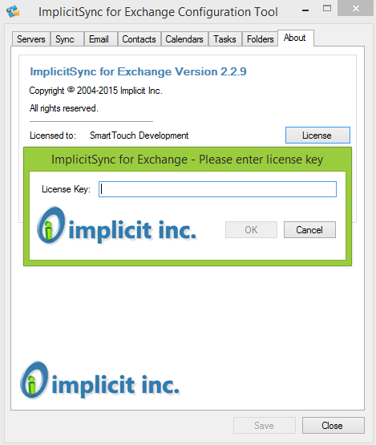

### SERVERS TAB

* On the **Servers** tab under the section called **CRM Server**, enter the User ID and Password for the Account Administrator user that you created in SmartTouch.

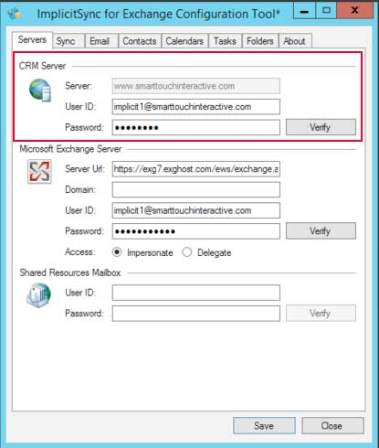

* On the **Servers** tab under the section called **Microsoft Exchange Server**, enter the Microsoft account credentials as follows:
  1. Server URL – enter the host information for your Exchange account
  2. Domain – can be left blank
  3. User ID – this is the email address of the SmartTouch Account Administrator user
  4. Password – this is the password of the SmartTouch Account Administrator user
  5. Access – select Impersonate

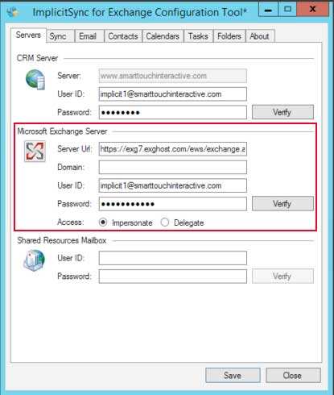

### CONFIGURING SYNC SETTINGS

* On the **Sync** tab, create your Synchronization settings.
  1. Set how frequent you would like to synchronize your Exchange account with your SmartTouch account.

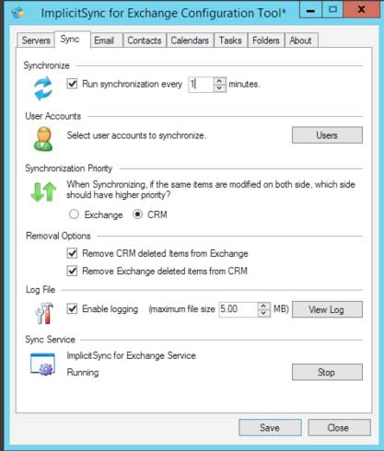

* 1. In the section called **Users**, click on the Users button to add your Exchange User Accounts to the configuration.

**ADDING USERS**

* Click **Users > Add User**

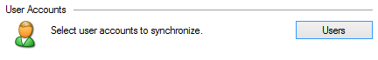

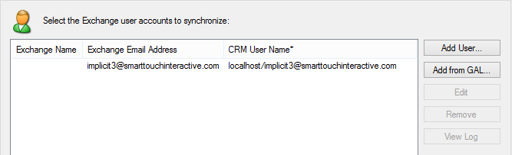

1. Enter the user’s Exchange Email Address in the **Exchange Email Address** field. This should match the email address used when you created the SmartTouch User Account. In the **CRM UserName** field, enter your SmartTouch **Account Name/User Email**. This will allow the correct User Account to be identified and properly synced.

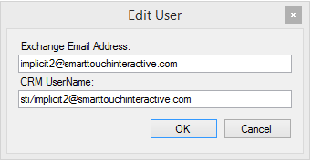 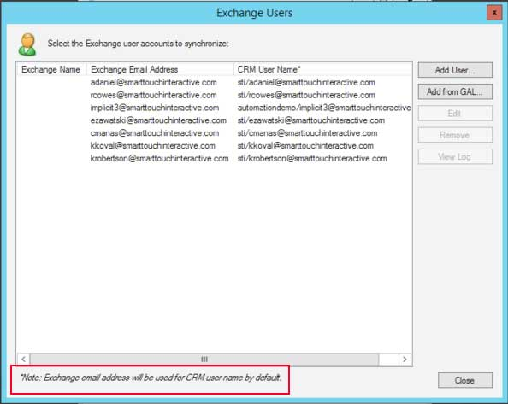

* In the section called **Synchronization Priority**, select CRM to maintain the higher priority.

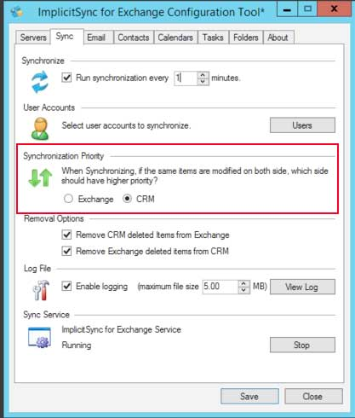

* In the section called **Removal Options**, check off both boxes to choose the provided removal parameters.

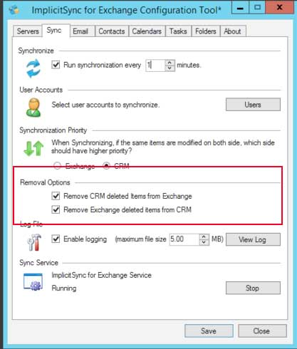

* In the section called **Log File**, be sure to select the check box beside Enable Logging.

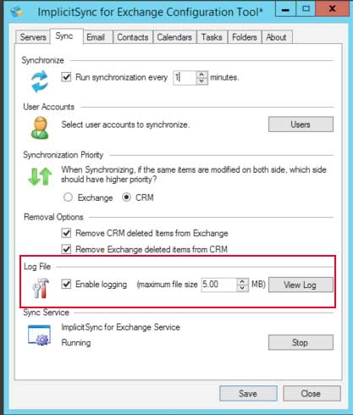

### CONFIGURING EMAIL

* Click on the **Email** tab and enter the configuration details to match *exactly* what is shown in the image below.

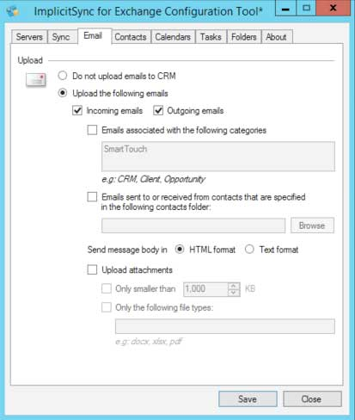

### CONFIGURING CONTACTS

* Click on the **Contacts** tab and enter the configuration details to match *exactly* what is shown in the image below. The Category (**SmartTouch)** is case sensitive and contains no spaces as shown.

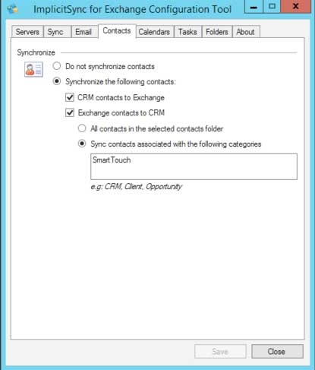

### CONFIGURING CALENDARS

* Click on the **Calendars** tab and enter the configuration details to match *exactly* what is shown in the image below. The Category (**SmartTouch**) is case sensitive and contains no spaces as shown.

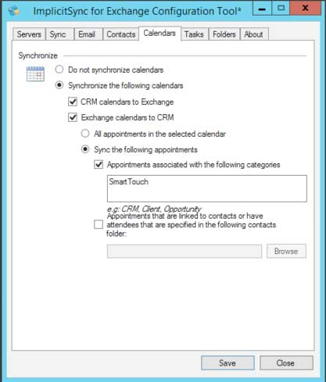

### CONFIGURING TASKS

* Click on the **Tasks** tab and and enter the configuration details to match *exactly* what is shown in the image below. **Exception:** Category (**SmartTouch**) is NOT REQUIRED as this is currently a one-way sync from the CRM to your email program only.

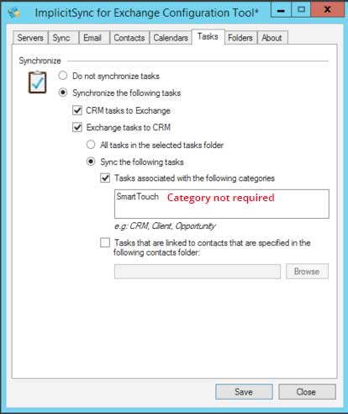

### STARTING SmartSynch SERVICE

* Return to the **Sync** tab and in the section called **Sync Service**, click on Start to begin synchronizing between SmartTouch and your configured Exchange user accounts.

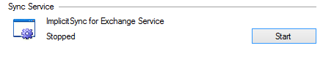

* Click Yes if prompted to save changes.

